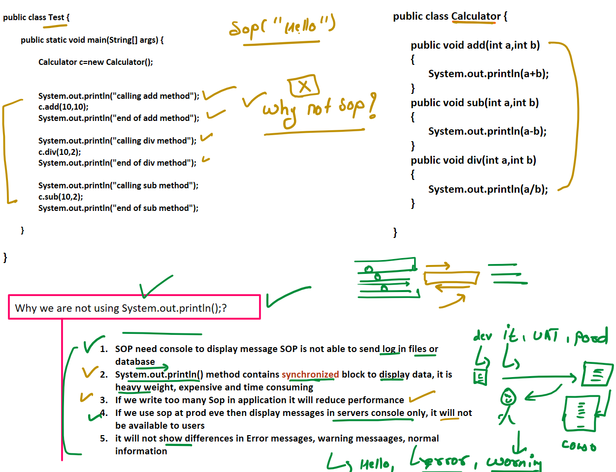  


C:\Users\Ashwani\AppData\Local\Microsoft\Windows\INetCache\Content.MSO\103AB822.tmp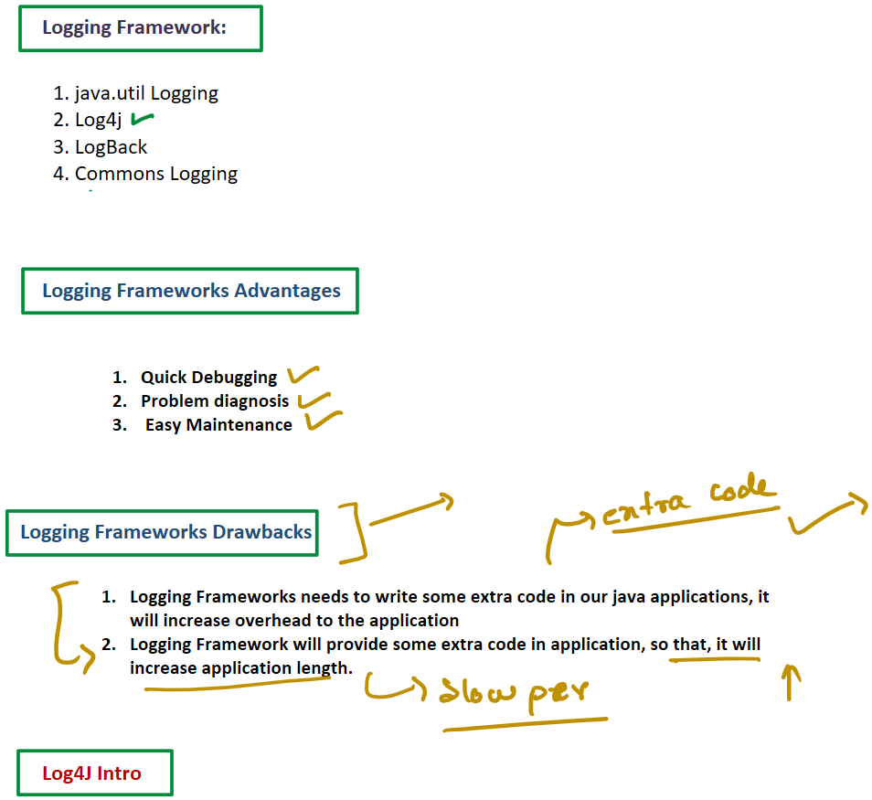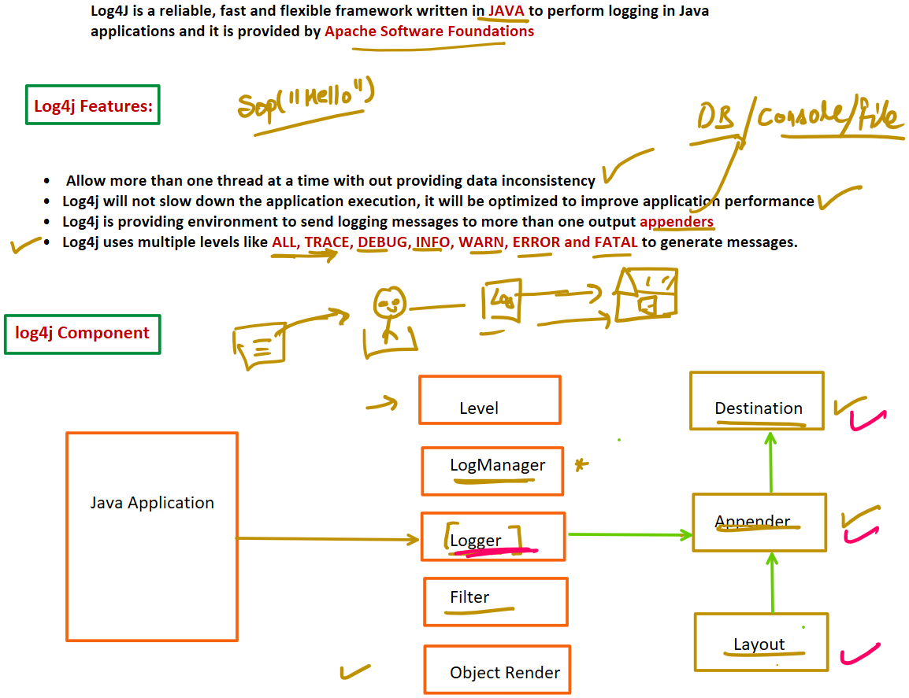**Note: There are 4 core object in Log4j**

|  |  |  |  |
| --- | --- | --- | --- |
|  |  |  |  |
|  | C:\Users\Ashwani\AppData\Local\Microsoft\Windows\INetCache\Content.MSO\70E481CC.tmp |  |  |
|  |  | Logger:  **This Object is responsible to get logging messages from Java applications** |
|  |  |  |

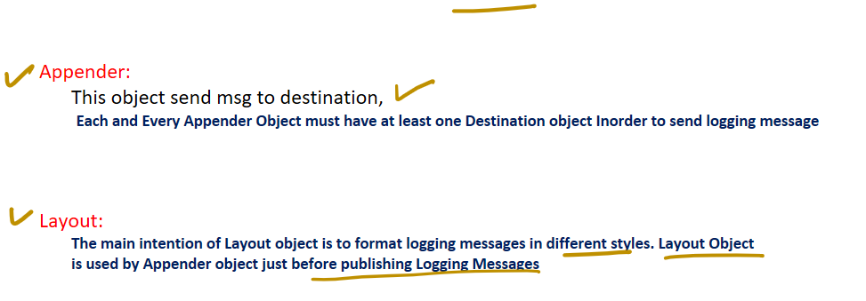Supporting Objects:

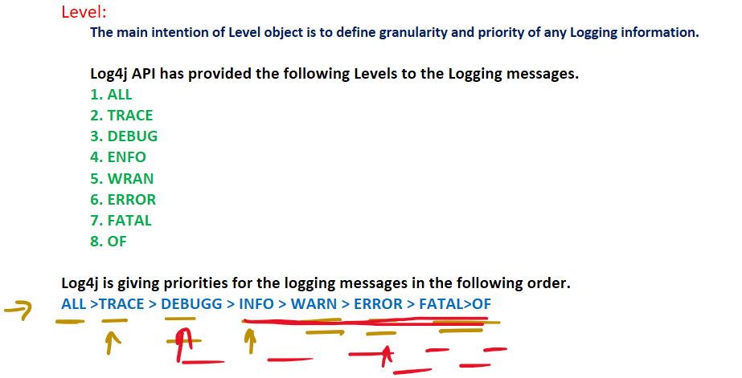LogManager:

**LogManager is the central component , it able to manage Log4j framework, it will read all the initial**

**configuration details from the configuration file**

